Project Planning Phase
Project Planning Template (Product Backlog, Sprint Planning, Stories, Story points)

Date | 2 October 2026
Team ID | Team 7  Team Members: Haresh S (Team Leader), Gobika M, Hariharan M, Harini G
Project Name | Streamlining IT Procurement: Automating Standard Laptop Orders with Flow Designer
Maximum Marks | 5 Marks

Product Backlog, Sprint Schedule, and Estimation (4 Marks)
Use the below template to create product backlog and sprint schedule
Sprint | Functional Requirement (Epic) | User Story Number | User Story / Task | Story Points | Priority | Team Members
Sprint-1 | Flow Creation | USN-1 | As an IT admin, I can open Flow Designer from Process Automation and create a new flow named "Standard laptop task" (Application: Global, Run user: System user). | 3 | High | Haresh S
Sprint-1 |  | USN-2 | As an IT admin, I can add the Service Catalog trigger to the flow so that it starts when a laptop request is placed. | 3 | High | Gobika M
Sprint-1 |  | USN-3 | As an IT admin, I can add the Create Catalog Task action and drag the Requested Item record into it so that a catalog task is created for every laptop request. | 5 | High | Hariharan M
Sprint-1 |  | USN-4 | As an IT admin, I can set the short description and description of the catalog task to "Laptop need to Configured" so that the hardware team knows what to do. | 3 | High | Harini G
Sprint-1 |  | USN-5 | As an IT admin, I can set the Assignment group to "Hardware" and Approval to "Approved" on the catalog task so that it reaches the right team. | 3 | High | Haresh S
Sprint-1 |  | USN-6 | As an IT admin, I can save and activate the flow so that it is ready to use. | 3 | High | Gobika M
Sprint-2 | Flow Assignment | USN-7 | As an IT admin, I can open Maintain Items and find the "Standard Laptop" catalog item. | 3 | High | Hariharan M
Sprint-2 |  | USN-8 | As an IT admin, I can open the Process engine tab of the catalog item and remove the existing automations. | 3 | Medium | Harini G
Sprint-2 |  | USN-9 | As an IT admin, I can add the "Standard Laptop Task" flow to the catalog item so that it runs for every laptop order. | 5 | High | Haresh S
Sprint-2 |  | USN-10 | As an IT admin, I can save the catalog item record so that the flow assignment is stored. | 2 | High | Gobika M
Sprint-2 | Service Catalog Ordering | USN-11 | As an employee, I can open Service Catalog > Hardware and find the "Standard Laptop" item. | 3 | High | Hariharan M
Sprint-2 |  | USN-12 | As an employee, I can click Order Now to place a request for a standard laptop. | 4 | High | Harini G
Sprint-3 | Approval and Task Generation | USN-13 | As an employee, I can see the order status and open the Request Number record after placing the order. | 3 | High | Gobika M
Sprint-3 |  | USN-14 | As an approver, I can approve the request from the Approvers section of the request record. | 5 | High | Haresh S
Sprint-3 |  | USN-15 | As a hardware team member, I can see a catalog task generated automatically in the Catalog tasks section of the Requested Item once the request is approved. | 5 | High | Hariharan M
Sprint-3 |  | USN-16 | As a hardware team member, I can see the short description "Laptop need to Configured" and the Hardware assignment group on the task so that I can configure the laptop promptly. | 4 | High | Harini G
Sprint-3 |  | USN-17 | As an IT procurement team member, I can confirm that the task is created without any manual intervention. | 3 | Medium | Gobika M
Sprint-4 | Testing and Documentation | USN-18 | As a tester, I can place a test order, approve it and verify that the catalog task is created end to end. | 5 | High | Harini G
Sprint-4 |  | USN-19 | As an IT admin, I can check the Flow Designer execution details to confirm that each run completed without errors. | 3 | Medium | Hariharan M
Sprint-4 |  | USN-20 | As a team member, I can fix any issues found during testing so that the flow works as expected. | 3 | Medium | Haresh S
Sprint-4 |  | USN-21 | As a team member, I can prepare the project documentation (design phase documents and project report). | 5 | Medium | Gobika M
Sprint-4 |  | USN-22 | As a stakeholder, I can see a final demo of the automated laptop order flow. | 4 | Low | Haresh S

Project Tracker, Velocity & Burndown Chart: (4 Marks)
Sprint | Total Story Points | Duration | Sprint Start Date | Sprint End Date (Planned) | Story Points Completed (as on Planned End Date) | Sprint Release Date (Actual)
Sprint-1 | 20 | 6 Days | 05 Oct 2026 | 10 Oct 2026
Sprint-2 | 20 | 6 Days | 12 Oct 2026 | 17 Oct 2026
Sprint-3 | 20 | 6 Days | 19 Oct 2026 | 24 Oct 2026
Sprint-4 | 20 | 6 Days | 26 Oct 2026 | 31 Oct 2026

Velocity:
Imagine we have a 6-day sprint duration, and the velocity of the team is 20 (points per sprint). Let’s calculate the team’s average velocity (AV) per iteration unit (story points per day)
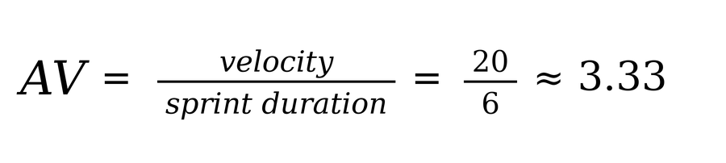

Burndown Chart:
A burn down chart is a graphical representation of work left to do versus time. It is often used in agile software development methodologies such as Scrum. However, burn down charts can be applied to any project containing measurable progress over time.

https://www.visual-paradigm.com/scrum/scrum-burndown-chart/
https://www.atlassian.com/agile/tutorials/burndown-charts

Reference:
https://www.atlassian.com/agile/project-management
https://www.atlassian.com/agile/tutorials/how-to-do-scrum-with-jira-software
https://www.atlassian.com/agile/tutorials/epics
https://www.atlassian.com/agile/tutorials/sprints
https://www.atlassian.com/agile/project-management/estimation
https://www.atlassian.com/agile/tutorials/burndown-charts

